BG Benthic grazer greenlip abalone, blacklip abalone, Purple sea urchin, gastropods, amphipods, Isopods Limpets and chitons

**Abalone** Stable isotopes of carbon suggest that brown algae and/detritus are a more important source of carbon than red algae. Fatty acid analysis confirmed the larger contribution of brown algae to the diet of abalone, and also identified the bacterial and diatom component of detritus to be an important contributor to abalone diet. These results show combined use of chemical tracers to be a promising technique for resolving abalone diet, and challenge current perceptions regarding spatial variability in abalone diet choice. adult abalone feed on the three main groups of macroalgae: brown, red, and green.

**Juveniles**: settle on corraline red algae, feed on benthic diatoms. Diatoms and bacteria may have been preferentially consumed at this early stage (Shepherd and Cannon 1988, Wood and Buxton 1996). Kawamura et al. (1998) reviewed the available information on the feeding habits and growth of abalone postlarvae and early juveniles (5-10 mm) and concluded that most of their diet consists of diatoms, bacterial films, and sporelings of macroalgae. Regarding diatom components of the diet, only scarce specimens of *Cocconeis* cf. *dirupta*

were observed in one *H. corrugata* stomach. A partial explanation for low occurrence is that

the average shell length (48 mm) of the juvenile abalone was greater than the size (5-10 mm) at which diatoms have been reported as an important part of juvenile and postlarval diet (Tomita and Tazawa 1971, Shepherd and Cannon 1988, Kawamura et al. 1998). Leighton (2000) indicated that in younger stages, abalone graze on particulate organic matter and microphytobenthos plankton, including diatoms. In other studies, however, abalone larger than 50 mm from Isla Magdalena, 400 km south of Bahia Tortugas, had abundant diatoms in their guts (SiqueirosBeltrones 2000, Siqueiros-Beltrones and Valenzuela-Romero 2001). All were epiphytic forms from both crustose and articulated corallines, as well as fleshy macroalgae. Abalone feed by trapping drtft algae as well as by grazing algae on the substratum (Poore 1972; Shepherd 1973; Tutschulte & Connell 1988). Wells and Keesing (1989) found that *H. roei on* intertidal platforms near Perth feeds primarily on drift algae, although Shepherd (1973) reported that, in South Australia, it is 'substantially a grazing species'.

**Sea urchins**: Grazing by sea urchins *(Echinometra matheii)* and herbivorous fish *{Kyphosus cornelii)* has marked effects on the distribution and abundance of macroalgae in the algal zone of platforms on Rottnest Island (Black & Johnson 1983; Berry & Playford 1992).

**Amphipods**: Gut contents of the studied amphipod species included mainly detritus and crustaceans, and secondly microalgae and polychaetes. According to the diet, species were included in three different feeding groups: detritivorous (6 species), carnivorous (5 species) and omnivorous (6 species) (Table 2). Despite many doubts about some species, due to the lack of information and their opportunistic behaviour, the identified taxa were grouped in the main categories of suspension feeders, deposit feeders, carnivores, commensals, herbivores, plant detritus feeders, omnivores, and in the mixed categories of deposit-suspension feeders, deposit feeders-carnivores, herbivores-deposit feeders, according to the food ingested and their feeding strategies. They are important secondary producers and exhibit diverse feeding strategies: grazing, filter and detritic feeding, predation and scavenging (macrophagy and microphagy) (Carrasco & Arcos, 1984; Highsmith & Coyle, 1990; Sarvala & Uitto, 1991).

**Juveniles:** In this study, we found the isopod J. nordmanni in the guts of field caught amphipods, E.marinus, fromjuveniles through to adults, indicating that E. marinus utilises an active predatory feeding mode in the wild. Further, under laboratory conditions, juvenile, sub-adult

and adult E. marinus exhibited Type II functional responses towards size-matched J. nordmanni prey. In addition, the largest adult E.marinus fed on the smallest J. nordmanni, again with Type II functional responses, in both homo- and heterogeneous habitats. As amphipod crustaceans are increasingly recognised as active predators (Bollache et al., 2008; Dick et al., 2005, 2012a; MacNeil et al., 1997), and marine inter-tidal communities are heavily influenced by predation, we have elucidated on the ontogeny of predation in the ubiquitous amphipod E. marinus.

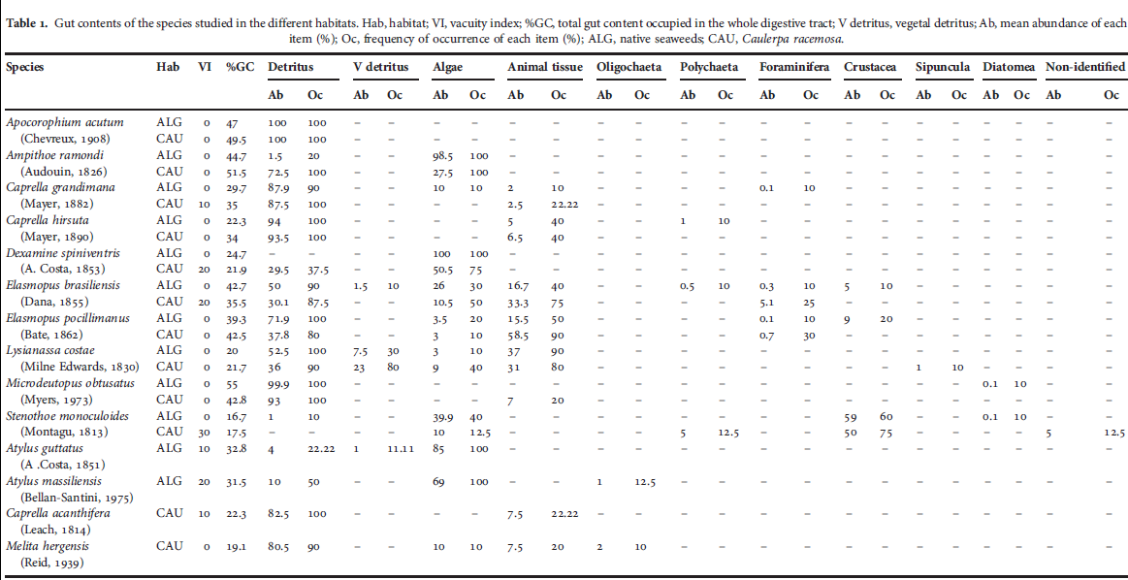

Stomach contents of a few phycophilous amphipods demonstrate that they probably feed on microscopic epiphytes. Gammaridea are presumed to be opportunistic scavengers or inquilines and their feeding behaviour is poorly known. A few true herbivores apparently occur and lately a few raptorial predators have been identified. Of course there are numerous kinds of scavenger feeding.

**Isopods**:

Four feeding categories are recognised as much on the basis of anecdotal evidence as hard data: detritus feeders and browsers, carnivores, parasites, and filter feeders. Carnivorous feeders can be further split into three groups— micropredators, predators and scavengers.

amphipod *Hyale perieri*

the isopods *Dynamene bidentata*  and *Ischyromene lacazei*

tanaid *Tanais dulongii*

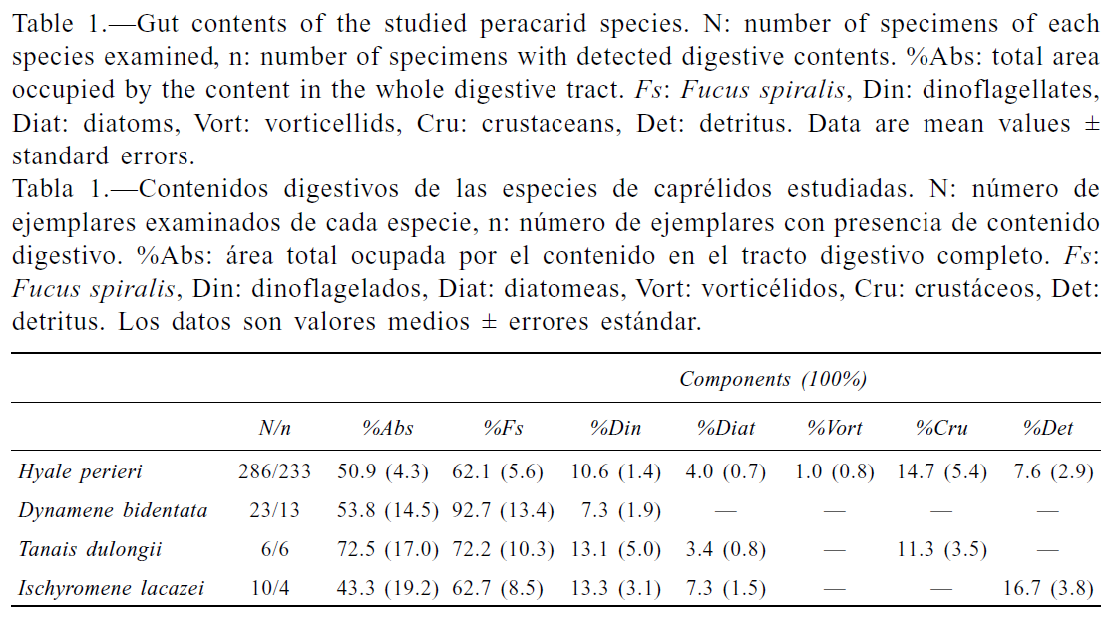

The largely unidentifiable remains of polychaetes and crustaceans were recovered in the gut contents of the November sample analysed (Table 4) of *Natatolana borealis* (Isopoda: Cirolanidae) Y. M.. Polychaete remains belonged mainly to infaunal families Maldanidae, Sabellidae, Terebellidae and Aphroditidae. Whether these were ingested alive or as carrion

cannot be ascertained.

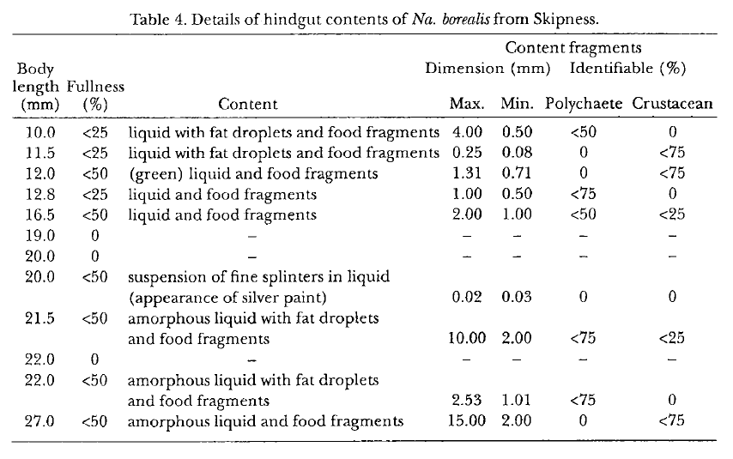

|  |  |
| --- | --- |
| **prey item** | **probability of consuming** |
| algae MA | 0.3 |
| DR detritus | 0.3 |
| DL detritus | 0.3 |
| BAC detritus | 0.3 |
| PL diatoms | 0.1 |
| MI microphytobenthos | 0.3 |
| BC polychaetes | 0.1 |
| BG crustaceans | 0.1 |
| ZME crustaceans | 0.1 |
| ZMI crustaceans | 0.1 |
| DC | 0.3 |

Reference

[Guest, MA](http://apps.webofknowledge.com/OneClickSearch.do?product=UA&search_mode=OneClickSearch&colName=WOS&SID=Y19Dd9vusDvYBFFnAZv&field=AU&value=Guest,%20MA&ut=12457309&pos=%7b2%7d&excludeEventConfig=ExcludeIfFromFullRecPage). [Nichols, PD](http://apps.webofknowledge.com/OneClickSearch.do?product=UA&search_mode=OneClickSearch&colName=WOS&SID=Y19Dd9vusDvYBFFnAZv&field=AU&value=Nichols,%20PD&ut=16117918&pos=%7b2%7d&excludeEventConfig=ExcludeIfFromFullRecPage), [,](http://apps.webofknowledge.com/OneClickSearch.do?product=UA&search_mode=OneClickSearch&excludeEventConfig=ExcludeIfFromFullRecPage&colName=WOS&SID=Y19Dd9vusDvYBFFnAZv&field=AU&value=Frusher,%20SD) [,](http://apps.webofknowledge.com/OneClickSearch.do?product=UA&search_mode=OneClickSearch&excludeEventConfig=ExcludeIfFromFullRecPage&colName=WOS&SID=Y19Dd9vusDvYBFFnAZv&field=AU&value=Hirst,%20AJ) 2008. Evidence of abalone (Haliotis rubra) diet from combined fatty acid and stable isotope analyses. MARINE BIOLOGY  Volume: 153   Issue: 4   Pages: 579-588

Sabine Daume , Sascha Brand & Wm. J. Woelkerling (1997) Effects of post-larval abalone (Haliotis rubra) grazing on the epiphytic diatom assemblage of coralline red algae, Molluscan Research, 18:2, 119-130

Robert E. Scheibling Molluscan grazing and macroalgal zonation on a rocky intertidal platform at Perth, Western Australia. *Australian Journal of Ecology* (1994) 19, 141-149

Sergio A. Guzman del Proo, Elisa Serviere-Zaragoza, and David Siqueiros-BeltronesSNatural Diet ofJuvenile Abalone *Haliotis fulgens* and *H. corrugate* (Mollusca: Gastropoda) in Bahia Tortugas, Mexico. Pacific Science (2003), vol. 57, no. 3:319-324

Carlos Navarro-Barranco , José Manuel Tierno-de-Figueroa, José Manuel Guerra-García ,

Luis Sánchez-Tocino, José Carlos García-Gómez. 2013. Feeding habits of amphipods (Crustacea: Malacostraca) from shallow soft bottom communities: Comparison between marine caves and open habitats. Journal of Sea Research 78, 1-7

Scopione, M.B. 2013. Do studies of functional groups give more insight to amphipod biodiversity? Crustaceana, 86 (7-8). 955-1006

Maite Vazquez-Luis, Pablo Sanchez-Jerez and Just T. Bayle-Sempere, 2013. Does the invasion of *Caulerpa racemosa* var. *cylindracea* affect the feeding habits of amphipods (Crustacea: Amphipoda)? Journal of the Marine Biological Association of the United Kingdom, 2013, 93(1), 87–94.

Mhairi E. Alexander, Jaimie T.A. Dick, Nessa E. O'Connor 2013. Born to kill: Predatory functional responses of the littoral amphipod Echinogammarus marinus Leach throughout its life history. Journal of Experimental Marine Biology and Ecology 439, 92-99

Torrecilla-Roca & J. M. Guerra-García. 2012 Feeding habits of the peracarid crustaceans associated to the alga *Fucus spiralis* in Tarifa Island, Cádiz (Southern Spain) Zoologica Baetica, vol. 23, 39-47

Y. M. Wong & P. G. Moore (1995) Biology of feeding in the scavenging isopod Natatolana borealis (Isopoda: Cirolanidae), Ophelia, 43:3, 181-196,

J. Laurens Barnard & Gordan S. Karaman. 1991. The Families and Genera of Marine Gammaridean Amphipoda (Except Marine Gammaroids). Records of the Australian Museum (1991) Supplement 13 (Part 1). ISBN 0 7305 8743 6 J

Poore GCB, Bruce NL (2012) Global Diversity of Marine Isopods (Except Asellota and Crustacean Symbionts). PLoS ONE 7(8):